
Tripoli Motor Testing Division
223 NC Highway 54 West
Chapel Hill, NC 27514
(919) 357 5681 (c)
September 21, 2023

Gary Rosenfield
RCS Rocket Motor Components, Inc.
2113 West 850 North Street
Cedar City, UT 84721

Dear Mr. Rosenfield,

The redesigned and reformulated Q-jet by Aerotech F41W single-use motor was tested on September 20, 2023 and complies with NFPA 1125. The motor is certified for hobby rocketry use by the members of the Tripoli Rocketry Association and all approving organizations with reciprocal certifying agreements.

Motor Manufacturer RCS Rocket Motor Components, Inc.
Manufacturer’s Designation {F41-5,8,11W } [single use]
Propellant White Lightning
TMT Nomenclature 48 F42

Diameter 0.937” 23.81 mm
Overall Length 4.449” 112.99 mm
Outside the MMT 0.193” 4.90 mm

Loaded Mass 0.1253 lb 56.855 g
Propellant Mass 0.060 lb* 27.1 g*
Burnout Mass 0.0541 lb 24.534 g
* = data provided by manufacturer

Burn time 1.115 ± 0.054 sec

Total Impulse 10.713 ± 0.380 lbf.s 47.651 ± 1.690 N.s
Max Impulse 12.176 ± 0.897 lbf 54.161 ± 3.990 N
Average Impulse 9.484 ± 0.673 lbf 42.185 ± 2.995 N
Number of Motors Tested 10

Nominal Measured
Delay Time Data 5 s 5.907, 4.972, 4.904, 5.415 s
8 s 8.752, 8.341, 8.322 s
11 s 11.004, 10.92, 11.426 s

Casing Temp. [NFPA 1125 7.4.1] Passed

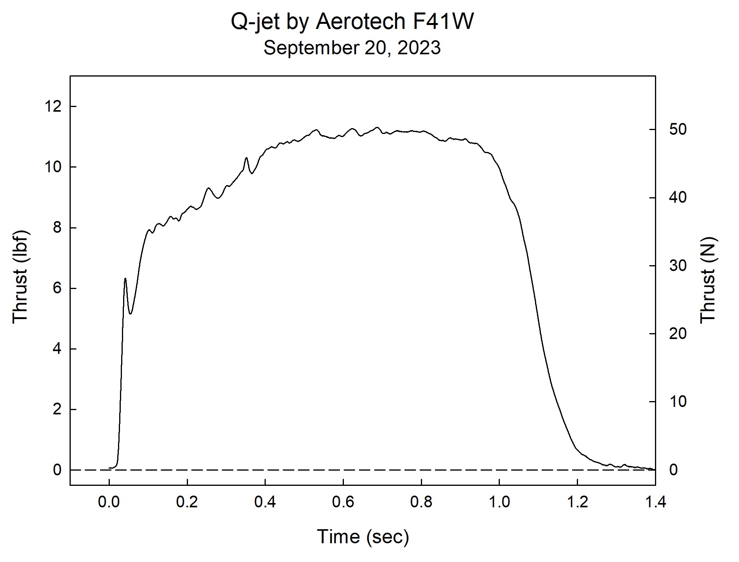

Sincerely,

Alan C. Whitmore
Chair, Tripoli Motor Testing

